Task2-1017-Vuppala Likitha

**1.write about IEEE 802 Standards.**

IEEE 802 is a collection of networking standards that cover the physical and data link layer specifications for technologies such as Ethernet and wireless. These specifications apply to local area networks ([LANs](https://www.techtarget.com/searchnetworking/definition/local-area-network-LAN)) and metropolitan area networks ([MANs](https://www.techtarget.com/searchnetworking/definition/metropolitan-area-network-MAN)).

Essentially, the IEEE 802 standards help make sure internet services and technologies follow a set of recommended practices so that network devices can all work together smoothly.

IEEE 802 is divided into different parts that cover the physical and [data link](https://www.techtarget.com/searchnetworking/definition/Data-Link-layer) aspects of networking. The family of standards is developed and maintained by the Institute of Electrical and Electronics Engineers (IEEE) 802 LAN/MAN Standards Committee, also called the LMSC.

The set of standards started in 1979 with a proposed standard called Local Network for Computer Interconnection, which was approved a year later. The LMSC has made more than 70 standards for IEEE 802.

Some commonly used standards include those for Ethernet, bridging and virtual bridged LANs, [wireless LANs, wireless MANs, wireless personal area networks](https://www.techtarget.com/searchnetworking/tip/The-4-different-types-of-wireless-networks) (PANs) and radio access networks, as well as media independent handover services.

Better-known specifications include [802.3 Ethernet](https://www.techtarget.com/searchnetworking/definition/8023), 802.11 Wi-Fi and 802.15 Bluetooth/Zigbee. However, some of these standards have been labeled as disbanded or hibernating, and are either superseded by newer standards or being reworked. Using an open process, the LMSC advocates for these standards globally.

Individual working groups are decided on and assigned to each area so that each segment receives an acceptable amount of focus. IEEE 802 specifications also split the data link layer into two different layers -- a logical link control layer and a media access control (MAC) layer.

LMSC provides a PDF of standards for up to six months after they have been published. All standards stay in place until they are replaced with another document or withdrawn.

**Why IEEE 802 standards are important**

LMSC was formed in 1980 to standardize [network protocols](https://www.techtarget.com/searchnetworking/definition/protocol) and provide a path to make compatible devices across numerous industries.

Without these standards, equipment suppliers could manufacture network hardware that would only connect to certain computers. It would be much more difficult to connect to systems not using the same set of networking equipment. Standardizing protocols helps ensure multiple types of devices can connect to multiple network types. It also helps make sure network management isn't the challenge it could be if standards weren't in place.

IEEE 802 also coordinates with other international standards, such as the International Organization for Standardization or ISO, to help maintain international standards.

The *802* in *IEEE 802* does not stand for anything of significance; 802 was the next numbered project.

**Examples of IEEE 802 uses**

Commercial organizations can use the IEEE 802 specifications to ensure their products maintain any newly specified standards. So, for example, the 802.11 specification that applies to Wi-Fi could be used to make sure Wi-Fi devices work together under one standard. In the same way, IEEE 802 can help maintain LAN standards.

These specifications also define what connectivity infrastructure will be used for -- individual networks or those at a larger organizational scale.

The IEEE 802 specifications apply to hardware and software products. So that manufacturers don't have any input on the standards, there is a voting protocol in place. This ensures one organization does not influence the standards too much.

IEEE 802:-

It is used for the overview and architecture of LAN/MAN

IEEE 802.1:-

It is used for bridging and management of LAN/MAN.

IEEE 802.1s:-

It is used in multiple spanning trees.

IEEE 802.1 w:-

It is used for rapid reconfiguration of spanning trees.

IEEE 802.1x:-

It is used for network access control of ports.

IEEE 802.2:-

It is used in Logical Link Control (LLC).

IEEE 802.3:-

It is used in Ethernet (CSMA/CD access method).

IEEE 802.3ae:-

It is used for 10 Gigabit Ethernet.

IEEE 802.4:-

It is used for token passing bus access methods and the physical layer specifications.

IEEE 802.5:-

It is used for token ring access methods and the physical layer specifications.

IEEE 802.6:-

It is used in distributed Queue Dual Bus (DQDB) access method and for the physical layer specifications (MAN).

IEEE 802.7:-

It is used in broadband LAN.

IEEE 802.8:-

It is used in fiber optics.

IEEE 802.9:-

It is used in isochronous LANs.

IEEE 802.10:-

It is used in interoperable LAN/MAN security.

IEEE 802.11:-

It is used in wireless LAN, MAC, and Physical layer specifications.

IEEE 802.12:-

It is used in the demand-priority access method, in the physical layer, and in repeater specifications.

IEEE 802.13:-

It is not used.

IEEE 802.14:-

It is used in cable modems (not used now).

IEEE 802.15:-

It is used in WPAN (Wireless Personal Area Network).

IEEE 802.16:-

It is used in Wireless MAN (Wireless Metropolitan Area Network).

IEEE 802.17:-

It is used in RPR access (Resilient Packet Ring).

**2.write briefly about Transmission Media and Types with images**

* Transmission media is a communication channel that carries the information from the sender to the receiver. Data is transmitted through the electromagnetic signals.
* The main functionality of the transmission media is to carry the information in the form of bits through **LAN**(Local Area Network).
* It is a physical path between transmitter and receiver in data communication.
* In a copper-based network, the bits in the form of electrical signals.
* In a fibre based network, the bits in the form of light pulses.
* In **OSI**(Open System Interconnection) phase, transmission media supports the Layer 1. Therefore, it is considered to be as a Layer 1 component.
* The electrical signals can be sent through the copper wire, fibre optics, atmosphere, water, and vacuum.
* The characteristics and quality of data transmission are determined by the characteristics of medium and signal.
* Transmission media is of two types are wired media and wireless media. In wired media, medium characteristics are more important whereas, in wireless media, signal characteristics are more important.
* Different transmission media have different properties such as bandwidth, delay, cost and ease of installation and maintenance.
* The transmission media is available in the lowest layer of the OSI reference model, i.e., **Physical layer**.

Some factors need to be considered for designing the transmission media:

* **Bandwidth:** All the factors are remaining constant, the greater the bandwidth of a medium, the higher the data transmission rate of a signal.
* **Transmission impairment:** When the received signal is not identical to the transmitted one due to the transmission impairment. The quality of the signals will get destroyed due to transmission impairment.
* **Interference:** An interference is defined as the process of disrupting a signal when it travels over a communication medium on the addition of some unwanted signal.

## **Classification Of Transmission Media:**

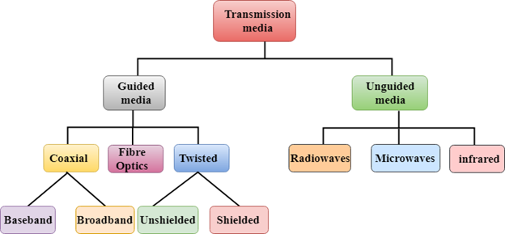

* [Guided Transmission Media](https://www.javatpoint.com/guided-transmission-media)
* [UnGuided Transmission Media](https://www.javatpoint.com/unguided-transmission-media)

# **Guided Media**

It is defined as the physical medium through which the signals are transmitted. It is also known as Bounded media.

Types Of Guided media:

## **Twisted pair:**

Twisted pair is a physical media made up of a pair of cables twisted with each other. A twisted pair cable is cheap as compared to other transmission media. Installation of the twisted pair cable is easy, and it is a lightweight cable. The frequency range for twisted pair cable is from 0 to 3.5KHz.

A twisted pair consists of two insulated copper wires arranged in a regular spiral pattern.

The degree of reduction in noise interference is determined by the number of turns per foot. Increasing the number of turns per foot decreases noise interference.

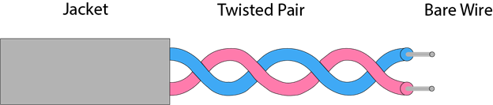

**Types of Twisted pair:**

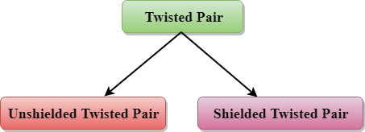

### Unshielded Twisted Pair:

An unshielded twisted pair is widely used in telecommunication. Following are the categories of the unshielded twisted pair cable:

* **Category 1:** Category 1 is used for telephone lines that have low-speed data.
* **Category 2:** It can support upto 4Mbps.
* **Category 3:** It can support upto 16Mbps.
* **Category 4:** It can support upto 20Mbps. Therefore, it can be used for long-distance communication.
* **Category 5:** It can support upto 200Mbps.

**Advantages Of Unshielded Twisted Pair:**

* It is cheap.
* Installation of the unshielded twisted pair is easy.
* It can be used for high-speed LAN.

**Disadvantage:**

* This cable can only be used for shorter distances because of attenuation.

### Shielded Twisted Pair

A shielded twisted pair is a cable that contains the mesh surrounding the wire that allows the higher transmission rate.

**Characteristics Of Shielded Twisted Pair:**

* The cost of the shielded twisted pair cable is not very high and not very low.
* An installation of STP is easy.
* It has higher capacity as compared to unshielded twisted pair cable.
* It has a higher attenuation.
* It is shielded that provides the higher data transmission rate.

**Disadvantages**

* It is more expensive as compared to UTP and coaxial cable.
* It has a higher attenuation rate.

## **Coaxial Cable**

* Coaxial cable is very commonly used transmission media, for example, TV wire is usually a coaxial cable.
* The name of the cable is coaxial as it contains two conductors parallel to each other.
* It has a higher frequency as compared to Twisted pair cable.
* The inner conductor of the coaxial cable is made up of copper, and the outer conductor is made up of copper mesh. The middle core is made up of non-conductive cover that separates the inner conductor from the outer conductor.
* The middle core is responsible for the data transferring whereas the copper mesh prevents from the **EMI**(Electromagnetic interference).

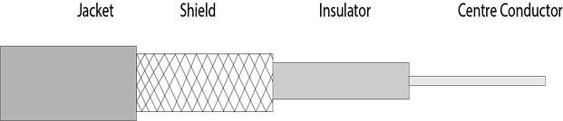

**Coaxial cable is of two types:**

1. **Baseband transmission:** It is defined as the process of transmitting a single signal at high speed.
2. **Broadband transmission:** It is defined as the process of transmitting multiple signals simultaneously.

**Advantages Of Coaxial cable:**

* The data can be transmitted at high speed.
* It has better shielding as compared to twisted pair cable.
* It provides higher bandwidth.

**Disadvantages Of Coaxial cable:**

* It is more expensive as compared to twisted pair cable.
* If any fault occurs in the cable causes the failure in the entire network.

## **Fibre Optic**

* Fibre optic cable is a cable that uses electrical signals for communication.
* Fibre optic is a cable that holds the optical fibres coated in plastic that are used to send the data by pulses of light.
* The plastic coating protects the optical fibres from heat, cold, electromagnetic interference from other types of wiring.
* Fibre optics provide faster data transmission than copper wires.

**Diagrammatic representation of fibre optic cable:**

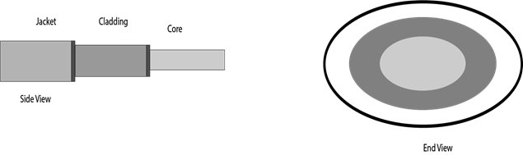

**Basic elements of Fibre optic cable:**

* **Core:** The optical fibre consists of a narrow strand of glass or plastic known as a core. A core is a light transmission area of the fibre. The more the area of the core, the more light will be transmitted into the fibre.
* **Cladding:** The concentric layer of glass is known as cladding. The main functionality of the cladding is to provide the lower refractive index at the core interface as to cause the reflection within the core so that the light waves are transmitted through the fibre.
* **Jacket:** The protective coating consisting of plastic is known as a jacket. The main purpose of a jacket is to preserve the fibre strength, absorb shock and extra fibre protection.

**Following are the advantages of fibre optic cable over copper:**

* **Greater Bandwidth:** The fibre optic cable provides more bandwidth as compared copper. Therefore, the fibre optic carries more data as compared to copper cable.
* **Faster speed:** Fibre optic cable carries the data in the form of light. This allows the fibre optic cable to carry the signals at a higher speed.
* **Longer distances:** The fibre optic cable carries the data at a longer distance as compared to copper cable.
* **Better reliability:** The fibre optic cable is more reliable than the copper cable as it is immune to any temperature changes while it can cause obstruct in the connectivity of copper cable.
* **Thinner and Sturdier:** Fibre optic cable is thinner and lighter in weight so it can withstand more pull pressure than copper cable.

# **UnGuided Transmission**

* An unguided transmission transmits the electromagnetic waves without using any physical medium. Therefore it is also known as **wireless transmission**.
* In unguided media, air is the media through which the electromagnetic energy can flow easily

Unguided transmission is broadly classified into three categories:

## **Radio waves**

* Radio waves are the electromagnetic waves that are transmitted in all the directions of free space.
* Radio waves are omnidirectional, i.e., the signals are propagated in all the directions.
* The range in frequencies of radio waves is from 3Khz to 1 khz.
* In the case of radio waves, the sending and receiving antenna are not aligned, i.e., the wave sent by the sending antenna can be received by any receiving antenna.
* An example of the radio wave is **FM radio**.

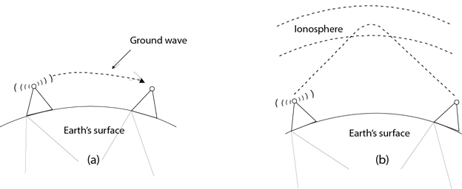

**Applications Of Radio waves:**

* A Radio wave is useful for multicasting when there is one sender and many receivers.
* An FM radio, television, cordless phones are examples of a radio wave.

**Advantages Of Radio transmission:**

* Radio transmission is mainly used for wide area networks and mobile cellular phones.
* Radio waves cover a large area, and they can penetrate the walls.
* Radio transmission provides a higher transmission rate.

## **Microwaves**

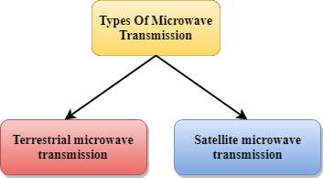

Microwaves are of two types:

* Terrestrial microwave
* Satellite microwave communication.

### Terrestrial Microwave Transmission

* Terrestrial Microwave transmission is a technology that transmits the focused beam of a radio signal from one ground-based microwave transmission antenna to another.
* Microwaves are the electromagnetic waves having the frequency in the range from 1GHz to 1000 GHz.
* Microwaves are unidirectional as the sending and receiving antenna is to be aligned, i.e., the waves sent by the sending antenna are narrowly focussed.
* In this case, antennas are mounted on the towers to send a beam to another antenna which is km away.
* It works on the line of sight transmission, i.e., the antennas mounted on the towers are the direct sight of each other.

**Characteristics of Microwave:**

* **Frequency range:** The frequency range of terrestrial microwave is from 4-6 GHz to 21-23 GHz.
* **Bandwidth:** It supports the bandwidth from 1 to 10 Mbps.
* **Short distance:** It is inexpensive for short distance.
* **Long distance:** It is expensive as it requires a higher tower for a longer distance.
* **Attenuation:** Attenuation means loss of signal. It is affected by environmental conditions and antenna size.

**Advantages Of Microwave:**

* Microwave transmission is cheaper than using cables.
* It is free from land acquisition as it does not require any land for the installation of cables.
* Microwave transmission provides an easy communication in terrains as the installation of cable in terrain is quite a difficult task.
* Communication over oceans can be achieved by using microwave transmission.

**Disadvantages of Microwave transmission:**

* **Eavesdropping:** An eavesdropping creates insecure communication. Any malicious user can catch the signal in the air by using its own antenna.
* **Out of phase signal:** A signal can be moved out of phase by using microwave transmission.
* **Susceptible to weather condition:** A microwave transmission is susceptible to weather condition. This means that any environmental change such as rain, wind can distort the signal.
* **Bandwidth limited:** Allocation of bandwidth is limited in the case of microwave transmission.

### Satellite Microwave Communication

* A satellite is a physical object that revolves around the earth at a known height.
* Satellite communication is more reliable nowadays as it offers more flexibility than cable and fibre optic systems.
* We can communicate with any point on the globe by using satellite communication.

**How Does Satellite work?**

The satellite accepts the signal that is transmitted from the earth station, and it amplifies the signal. The amplified signal is retransmitted to another earth station.

**Advantages Of Satellite Microwave Communication:**

* The coverage area of a satellite microwave is more than the terrestrial microwave.
* The transmission cost of the satellite is independent of the distance from the centre of the coverage area.
* Satellite communication is used in mobile and wireless communication applications.
* It is easy to install.
* It is used in a wide variety of applications such as weather forecasting, radio/TV signal broadcasting, mobile communication, etc.

**Disadvantages Of Satellite Microwave Communication:**

* Satellite designing and development requires more time and higher cost.
* The Satellite needs to be monitored and controlled on regular periods so that it remains in orbit.
* The life of the satellite is about 12-15 years. Due to this reason, another launch of the satellite has to be planned before it becomes non-functional.

## **Infrared**

* An infrared transmission is a wireless technology used for communication over short ranges.
* The frequency of the infrared in the range from 300 GHz to 400 THz.
* It is used for short-range communication such as data transfer between two cell phones, TV remote operation, data transfer between a computer and cell phone resides in the same closed area.

**Characteristics Of Infrared:**

* It supports high bandwidth, and hence the data rate will be very high.
* Infrared waves cannot penetrate the walls. Therefore, the infrared communication in one room cannot be interrupted by the nearby rooms.
* An infrared communication provides better security with minimum interference.
* Infrared communication is unreliable outside the building because the sun rays will interfere with the infrared waves.

**3.write briefly about topology**

A network topology is the physical and logical arrangement of nodes and connections in a network. Nodes usually include devices such as switches, routers and software with switch and router features. Network topologies are often represented as a graph.

Network topologies describe the arrangement of networks and the relative location of traffic flows. Administrators can use network topology diagrams to determine the best placements for each [node](https://www.techtarget.com/searchnetworking/definition/node) and the optimal path for traffic flow. With a well-defined and planned-out network topology, an organization can more easily locate faults and fix issues, improving its data transfer efficiency.

Network geometry can be defined as the physical topology and the logical topology. Network topology diagrams are shown with devices depicted as network nodes and the connections between them as lines. The type of network topology differs depending on how the network needs to be arranged.

### Why is network topology important?

Network topology plays a major role in how a network functions. Namely, the topology has a direct effect on network functionality. Choosing the right topology can help increase performance, as a properly chosen and maintained network topology increases energy efficiency and [data transfer rates](https://www.techtarget.com/searchunifiedcommunications/definition/data-transfer-rate).

A well-defined network topology makes it easier for network admins to locate faults, troubleshoot issues and to allocate network resources. Diagrams are an important reference point in helping to diagnose network issues, as they can represent physical and logical layouts.

### What are the types of network topologies?

Network topologies are categorized as either a physical network topology or logical network topology. The physical topology of a network is the physical layout of nodes and connections. Connections include the lines in diagrams that connect nodes, such as [Ethernet](https://www.techtarget.com/searchnetworking/definition/Ethernet) or Digital Subscriber Line wires, fiber optics and microwaves. Logical network topologies define how a network is set up, including which nodes connect and how, as well as the pattern of data transfers.

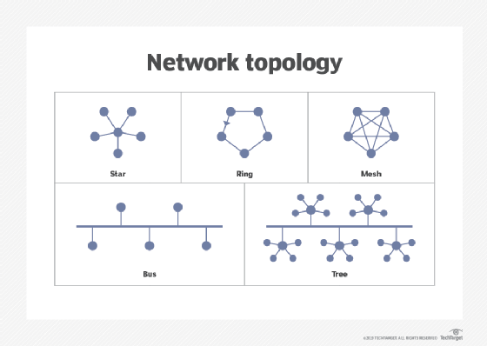This image shows different layouts of network topologies.

There are several types of topologies. For example, physical topologies include the following:

* **Bus network.** In the [bus network](https://www.techtarget.com/searchnetworking/definition/bus-network) topology, every node is connected in series along a single cable. This arrangement is found today primarily in cable broadband distribution networks.
* **Star network.** In the [star network](https://www.techtarget.com/searchnetworking/definition/star-network) topology, a central device connects to all other nodes through a central hub. Switched local area networks based on Ethernet switches and most wired home and office networks have a physical star topology.
* **Ring network.** In the [ring network](https://www.techtarget.com/whatis/definition/ring-network) topology, the nodes are connected in a closed-loop [configuration](https://www.techtarget.com/whatis/definition/configuration). Some rings pass data in one direction only, while others are capable of transmission in both directions. These bidirectional ring networks are more resilient than bus networks since traffic can reach a node by moving in either direction. Metro networks based on Synchronous Optical Network technology are the primary example of ring networks.
* **Mesh network.** The [mesh network](https://internetofthingsagenda.techtarget.com/definition/mesh-network-topology-mesh-network) topology links nodes with connections so that multiple paths between at least some points of the network are available. A network is considered to be fully meshed if all nodes are directly connected to all other nodes and partially meshed if only some nodes have multiple connections to others. Meshing multiple paths increases resiliency but also increases cost. However, more space is needed for dedicated links.
* **Tree network.** The tree network topology consists of one root node, and all other nodes are connected in a hierarchy. The topology itself is connected in a star configuration. Many larger Ethernet switch networks, including data center networks, are configured as trees.
* **Hybrid network.** The hybrid network topology is any combination of two or more topologies. Hybrid topologies typically provide exceptional flexibility, as they can accommodate a number of setups. For example, different departments in the same organization may opt for personalized network topologies that are more adaptable to their network needs.

**4.write in detail about OSI Model**

The Open Systems Interconnection (OSI) model describes seven layers that computer systems use to communicate over a network. It was the first standard model for network communications, adopted by all major computer and telecommunication companies in the early 1980s

The modern Internet is not based on OSI, but on the simpler TCP/IP model. However, the OSI 7-layer model is still widely used, as it helps visualize and communicate how networks operate, and helps isolate and troubleshoot networking problems.

**OSI 7 Layers**

**1.Physical Layer**:-The physical layer is responsible for the physical cable or wireless connection between network nodes. It defines the connector, the electrical cable or wireless technology connecting the devices, and is responsible for transmission of the raw data, which is simply a series of 0s and 1s, while taking care of bit rate control.

**2. Data Link Layer**:-The data link layer establishes and terminates a connection between two physically-connected nodes on a network. It breaks up packets into frames and sends them from source to destination. This layer is composed of two parts—Logical Link Control (LLC), which identifies network protocols, performs error checking and synchronizes frames, and Media Access Control (MAC) which uses MAC addresses to connect devices and define permissions to transmit and receive data.

**3. Network Layer**:-The network layer has two main functions. One is breaking up segments into network packets, and reassembling the packets on the receiving end. The other is routing packets by discovering the best path across a physical network. The network layer uses network addresses (typically Internet Protocol addresses) to route packets to a destination node.

**4. Transport Layer**:-The transport layer takes data transferred in the session layer and breaks it into “segments” on the transmitting end. It is responsible for reassembling the segments on the receiving end, turning it back into data that can be used by the session layer. The transport layer carries out flow control, sending data at a rate that matches the connection speed of the receiving device, and error control, checking if data was received incorrectly and if not, requesting it again.

**5. Session Layer**:-The session layer creates communication channels, called sessions, between devices. It is responsible for opening sessions, ensuring they remain open and functional while data is being transferred, and closing them when communication ends. The session layer can also set checkpoints during a data transfer—if the session is interrupted, devices can resume data transfer from the last checkpoint.

**6. Presentation Layer**:-The presentation layer prepares data for the application layer. It defines how two devices should encode, encrypt, and compress data so it is received correctly on the other end. The presentation layer takes any data transmitted by the application layer and prepares it for transmission over the session layer.

**7. Application Layer**:-The application layer is used by end-user software such as web browsers and email clients. It provides protocols that allow software to send and receive information and present meaningful data to users. A few examples of application layer protocols are the [Hypertext Transfer Protocol](https://www.imperva.com/learn/performance/http2/) (HTTP), File Transfer Protocol (FTP), Post Office Protocol (POP), Simple Mail Transfer Protocol (SMTP), and Domain Name System (DNS).

**5.write about TCP/IP.**

TCP/IP Reference Model is a four-layered suite of communication protocols. It was developed by the DoD (Department of Defence) in the 1960s. It is named after the two main protocols that are used in the model, namely, TCP and IP. TCP stands for Transmission Control Protocol and IP stands for Internet Protocol.

The four layers in the TCP/IP protocol suite are −

* **Host-to- Network Layer −**It is the lowest layer that is concerned with the physical transmission of data. TCP/IP does not specifically define any protocol here but supports all the standard protocols.
* **Internet Layer −**It defines the protocols for logical transmission of data over the network. The main protocol in this layer is Internet Protocol (IP) and it is supported by the protocols ICMP, IGMP, RARP, and ARP.
* **Transport Layer −** It is responsible for error-free end-to-end delivery of data. The protocols defined here are Transmission Control Protocol (TCP) and User Datagram Protocol (UDP).
* **Application Layer −** This is the topmost layer and defines the interface of host programs with the transport layer services. This layer includes all high-level protocols like Telnet, DNS, HTTP, FTP, SMTP, etc.

The following diagram shows the layers and the protocols in each of the layers −

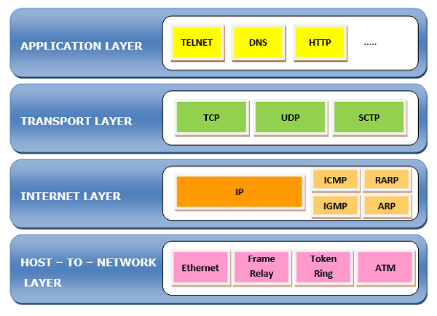

### Uses of TCP/IP

TCP/IP can be used to provide remote login over the network for interactive file transfer to deliver email, to deliver webpages over the network and to remotely access a server host's file system. Most broadly, it is used to represent how information changes form as it travels over a network from the concrete physical layer to the abstract application layer. It details the basic protocols, or methods of communication, at each layer as information passes through.

Common TCP/IP protocols include the following:

* **Hypertext Transfer Protocol (HTTP)** handles the communication between a web server and a web browser.
* [**HTTP Secure**](https://www.techtarget.com/searchsoftwarequality/definition/HTTPS) handles secure communication between a web server and a web browser.
* **File Transfer Protocol** handles transmission of files between computers.

**6.check your MAC address using cmd and mention it here.**

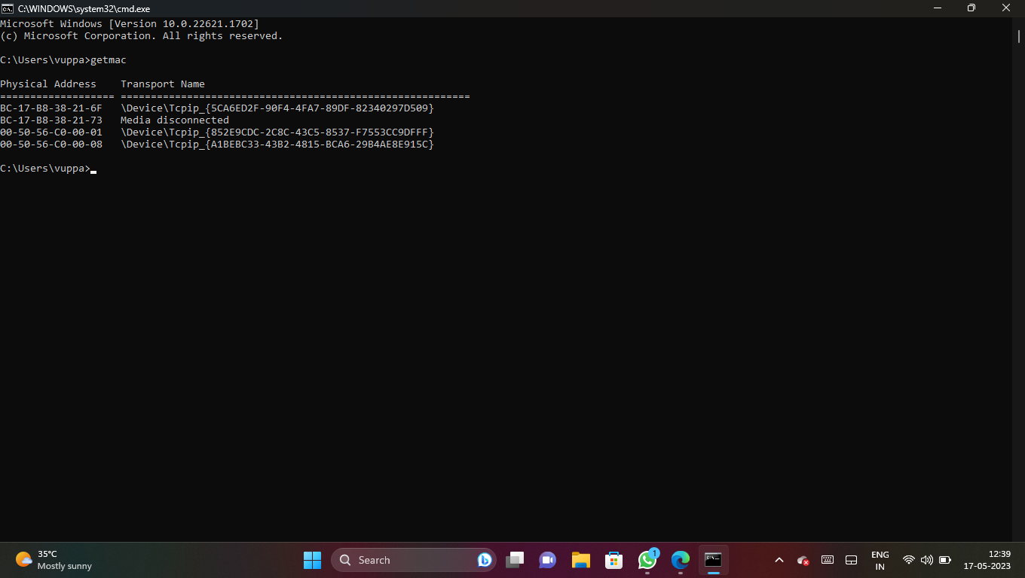

**7.write about Regional Internet Registries[RIR]**

# Regional Internet Registries

There are five Regional Internet Registries (RIRs) in the world. RIRs manage, distribute, and register Internet number resources ([IPv4 and IPv6](http://www.nro.net/about/rirs/internet-number-resources/ipv6-and-ipv4/) address space and Autonomous System (AS) Numbers) within their respective regions.

A **regional Internet registry** (**RIR**) is an organization that manages the allocation and registration of [Internet number](https://en.wikipedia.org/wiki/Internet_number) resources within a region of the world. Internet number resources include [IP addresses](https://en.wikipedia.org/wiki/IP_address) and [autonomous system (AS)](https://en.wikipedia.org/wiki/Autonomous_system_(Internet)) numbers.

The regional Internet registry system evolved, eventually dividing the responsibility for management to a registry for each of five regions of the world. The regional Internet registries are informally liaised through the unincorporated **Number Resource Organization** (NRO), which is a coordinating body to act on matters of global importance

